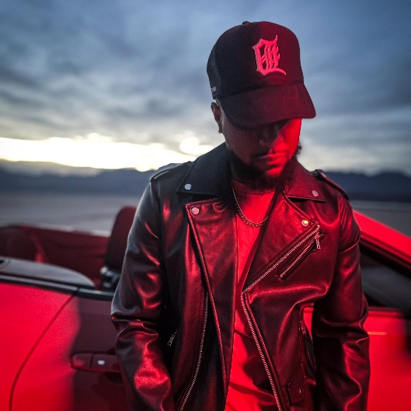

**Customer Profile # 1:** Malik “MC Flow Johnson (Independent Rap Artist)

|  |  |
| --- | --- |
| Attribute | Details |
| Name: | Malik "MC Flow" Johnson |
| Occupation: | Independent Rap Artist |
| Location: | Atlanta, Georgia, USA |
| Age: | 28 |
| Background: | Malik "MC Flow" Johnson is an up-and-coming rap artist based in Atlanta. With a passion for storytelling and lyrical prowess, Malik has been honing his craft since a young age. Growing up in the vibrant hip-hop scene of Atlanta, Malik draws inspiration from the city's rich musical history and diverse culture. Despite facing challenges in his journey, including limited resources and industry connections, Malik remains determined to make a name for himself in the music industry. His music reflects his experiences, struggles, and aspirations, resonating with listeners who appreciate authenticity and raw talent. Malik recognizes the power of the internet in reaching a global audience and is eager to leverage digital platforms to gain exposure and achieve monetary gains. |
| Goals: | 1. To increase his visibility and reach as a rap artist, both locally and globally. 2. To build a loyal fan base that resonates with his music and supports his career. 3. To monetize his music through various channels, including streaming platforms, merchandise sales, and live performances. 4. To collaborate with other artists and industry professionals to expand his network and opportunities. 5. To establish himself as a respected and influential figure in the hip-hop community. |
| Challenges: | 1. Standing out in a highly competitive music industry flooded with aspiring artists. 2. Generating consistent income from his music endeavors to support his career and lifestyle. 3. Navigating the complexities of digital marketing and social media promotion to effectively promote his music. 4. Balancing creative expression with commercial viability to appeal to a broad audience without compromising artistic integrity. 5. Overcoming skepticism and gaining recognition from established figures and industry gatekeepers. |
| Motivations: | 1. To share his unique voice and perspective with the world through his music. 2. To inspire and connect with listeners who relate to his lyrics and stories. 3. To achieve financial independence and stability through his passion for music. 4. To leave a lasting legacy in the hip-hop genre and contribute to its evolution. 5. To prove his doubters wrong and fulfill his potential as an artist. |
| Preferred Communication Styles: | 1. **Social Media:** Malik utilizes platforms like Instagram, Twitter, and TikTok to engage with his audience, share updates about his music, and connect with fans and fellow artists. 2. **Emails and Direct Messages:** Malik welcomes inquiries for collaborations, performance opportunities, and business ventures through email and direct messages on social media. 3. **In-Person Meetings and Performances:** Malik values face-to-face interactions and live performances as opportunities to connect with fans and industry professionals on a personal level. |
| Pain Points: | 1. **Limited Resources:** Malik faces constraints in terms of financial resources, studio equipment, and promotional budget, hindering his ability to fully realize his musical vision. 2. **Visibility and Exposure:** Breaking through the noise and gaining recognition in a crowded music landscape poses a significant challenge for Malik. 3. **Monetization:** Generating sustainable income from his music remains a constant struggle for Malik, impacting his ability to invest in his career and pursue his passion full-time. 4. **Navigating the Industry:** Malik finds it daunting to navigate the complex music industry landscape, including contracts, royalties, and marketing strategies, without proper guidance and support. 5. **Self-Doubt and Criticism:** Despite his talent and dedication, Malik grapples with self-doubt and criticism from skeptics, which can affect his confidence and motivation as an artist. |
| Solutions: | 1. **Strategic Branding:** Malik can develop a unique brand identity and storytelling narrative that sets him apart from other artists and resonates with his target audience. 2. **Digital Marketing:** Leveraging targeted advertising campaigns, social media promotion, and content marketing can help Malik increase his online visibility and attract new fans. 3. **Diversified Revenue Streams:** In addition to music sales and streaming royalties, Malik can explore alternative revenue streams such as merchandise sales, live performances, sponsorships, and licensing opportunities. 4. **Networking and Collaborations:** Building relationships with fellow artists, producers, promoters, and industry professionals can open doors to new opportunities and collaborations that elevate Malik's career. |

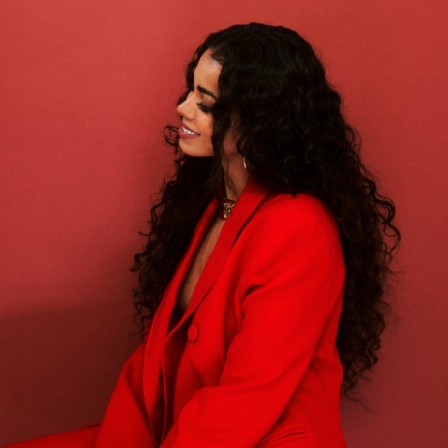

**Customer Profile#2:** Tahmina Q

(Social Media Brand Consultant)

|  |  |
| --- | --- |
| Attribute | Details |
| Name: | Tahmina Q |
| Occupation: | Social Media Brand Consultant |
| Location: | Toronto, Ontario, Canada |
| Age: | 31 |
| Background: | Tahmina Q is a seasoned social media brand consultant based in Toronto. With over 12 years of experience in the industry, Tahmina specializes in assisting local industry leaders, business owners, and creatives in infusing their personalities into their online presence. Her approach aims to foster genuine connections with the audience while ensuring a return on investment through strategic and compelling calls-to-action. Five years ago, Tahmina took the leap to establish her own company, The Brand Agents, carving out a successful path. Her diverse client roster includes collaborations with notable names like Jully Black, Miami Dolphins, Jaguar Canada, Body By Chosen, Celebrity makeup artist Prerna & Co., and more. Tahmina's achievements extend beyond her client portfolio, earning her media coverage from reputable outlets such as Walk in My Stilettos Podcast, Bold Journey, Voyage Magazine, Flow93.5 Radio station, and more. She continues to excel by connecting with a broad range of industries and emphasizing the human element in businesses' online presence. |
| Goals: | 1. To help clients enhance their brand visibility and reputation in the local market. 2. To establish meaningful connections between clients and their target audience. 3. To implement innovative social media strategies that drive tangible business outcomes. 4. To stay ahead of competitors and position her company as an industry leader. 5. To collaborate with clients who value authenticity and creativity in their online branding efforts. |
| Challenges: | 1. Ensuring that clients' brand personalities are effectively communicated online. 2. Crafting compelling calls-to-action that resonate with the target audience. 3. Ensuring that social media efforts translate into measurable results and ROI for clients. 4. Keeping up with the ever-evolving digital landscape and industry trends. 5. Finding clients who understand the importance of infusing authenticity and personality into their online presence. |
| Motivations: | 1. To help clients succeed in their online branding and marketing endeavors. 2. To make a positive impact on clients' businesses by driving meaningful results. 3. To build long-lasting relationships with clients based on trust and mutual respect. 4. To continuously learn and grow in the field of social media branding and consultancy. 5. To showcase her expertise and establish herself as a reputable industry leader. |
| Preferred Communication Styles: | 1. **Face-to-Face Meetings:** Tahmina prefers direct, in-person interactions where she can establish rapport and understand her clients' needs on a deeper level. 2. **Video Calls:** When face-to-face meetings are not feasible, Tahmina opts for video calls to facilitate real-time communication and maintain a personal touch. 3. **Emails:** For formal communication and documentation purposes, Tahmina relies on emails to convey detailed information and follow-up on discussions. |
| Pain Points: | 1. **Difficulty in Finding Ideal Clients:** Tahmina often struggles to find clients who fully appreciate the value of her services and the importance of authentic branding. 2. **Time Constraints:** Balancing multiple client projects while staying updated with industry trends and innovations can be challenging for Tahmina. 3. **Measuring ROI:** Demonstrating the tangible results of social media efforts to clients and ensuring a positive ROI remains a constant challenge. |
| Solutions: | 1. **Targeted Marketing:** Tahmina can focus her marketing efforts on industries and businesses known for valuing authenticity and creativity in branding, increasing the likelihood of finding ideal clients. 2. **Effective Time Management:** Implementing efficient project management tools and techniques can help Tahmina streamline her workflow and allocate time effectively across various tasks. 3. **Data Analytics:** Leveraging advanced analytics tools to track key performance indicators and demonstrate the impact of social media campaigns can enhance Tahmina's ability to showcase ROI to clients. |
|  |  |

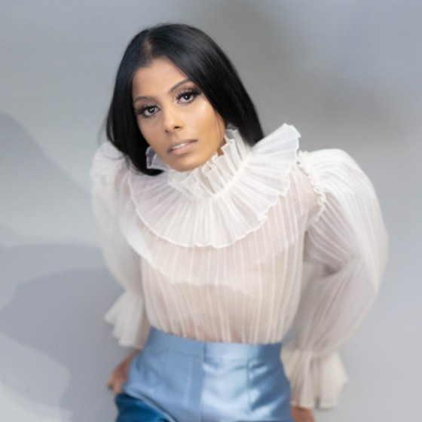

**CUSTOMER PROFILE # 3:**

Sophia Ramirez

(Fashion Entrepreneur)

|  |  |
| --- | --- |
| **Attribute** | Details |
| Name: | Sophia Ramirez |
| **Occupation:** | Fashion Entrepreneur |
| **Location:** | Los Angeles, California, USA |
| **Age:** | 28 |
| **Background:** | Sophia Ramirez is a visionary fashion entrepreneur based in the vibrant city of Los Angeles. With a passion for style and innovation, Sophia is on a mission to disrupt the fashion industry with her unique approach to design and retail. Drawing inspiration from the eclectic mix of cultures and trends in LA, Sophia envisions launching a fashion startup that caters to the needs and preferences of modern consumers. Her startup aims to offer a curated selection of clothing, accessories, and lifestyle products that embody creativity, sustainability, and inclusivity. Recognizing the pivotal role of technology in shaping the future of fashion retail, Sophia is eager to develop a mobile application that serves as the cornerstone of her business strategy. The MVP app will not only showcase her brand's aesthetic and offerings but also provide a seamless shopping experience for users, fostering engagement and loyalty from the outset. Sophia's entrepreneurial spirit, coupled with her keen eye for design and market trends, positions her as a trailblazer in the fashion landscape, poised to make a lasting impact with her startup venture. |
| **Goals:** | 1. To launch a Minimum Viable Product (MVP) mobile application that introduces the brand to the market and attracts early adopters. 2. To create a seamless and engaging shopping experience for users, driving conversions and building brand loyalty. 3. To establish a strong online presence and expand the startup's reach beyond the local market to a global audience of fashion enthusiasts. 4. To gather valuable feedback from users to iteratively refine the app and product offerings based on their preferences and needs. 5. To position the startup as a leading player in the fashion e-commerce space, known for its innovative approach to design, sustainability, and customer experience. |
| **Challenges:** | 1. Defining the brand identity and aesthetic to resonate with the target audience while standing out in a competitive fashion market. 2. Balancing creativity and functionality in app design to deliver an intuitive user experience without compromising on visual appeal. 3. Navigating the complexities of e-commerce logistics, inventory management, and supply chain operations to ensure seamless order fulfillment and customer satisfaction. 4. Overcoming budget constraints and resource limitations to develop and launch the MVP app within a reasonable timeframe. 5. Anticipating and addressing potential challenges related to user acquisition, retention, and competition in the highly dynamic fashion e-commerce landscape. |
| **Motivations:** | 1. To express her creative vision and passion for fashion through her startup venture, bringing her unique perspective to the industry. 2. To empower customers to embrace their individuality and personal style through a diverse range of curated fashion offerings. 3. To champion sustainability and ethical practices in fashion by partnering with eco-conscious brands and implementing responsible production and sourcing methods. 4. To foster a sense of community and inclusivity among users, connecting them through shared interests and values in fashion and lifestyle. 5. To build a successful and profitable business that not only generates revenue but also makes a positive impact on society and the environment. |
| **Preferred Communication Styles:** | 1. Visual Presentations: Sophia prefers visual presentations and mood boards to convey her brand's aesthetic, design inspiration, and vision for the MVP app. 2. Virtual Workshops: Interactive virtual workshops and brainstorming sessions with designers, developers, and stakeholders facilitate collaboration and idea generation for app development. 3. Feedback Surveys: Sending out feedback surveys to potential users and focus groups helps gather valuable insights and preferences for app features and functionality. 4. Social Media Engagement: Leveraging social media platforms such as Instagram, Pinterest, and TikTok to engage with the fashion community, share updates about the startup, and gather user feedback in real-time. 5. Email Correspondence: Utilizing email correspondence for formal documentation, project updates, and communication with app development partners and investors ensures clear and organized communication channels. |
| **Pain Points:** | 1. Brand Differentiation: Standing out in a crowded fashion market and carving a distinct identity for the startup amidst established competitors pose challenges. 2. Technical Expertise: Overcoming technical hurdles and navigating the app development process without prior experience in mobile technology requires specialized knowledge and support. 3. Inventory Management: Managing inventory, product catalog, and stock levels effectively to meet customer demand and minimize supply chain disruptions is crucial for operational efficiency. 4. User Engagement: Capturing and retaining user interest and engagement on the app amidst distractions and competition from other fashion platforms requires innovative marketing strategies and compelling content. 5. Financial Constraints: Securing funding and managing budget allocations for app development, marketing, and operational expenses within limited resources is a constant concern for the startup. |
| **Solutions:** | 1. Brand Storytelling: Crafting a compelling brand narrative and storytelling approach that resonates with the target audience's lifestyle, values, and aspirations. 2. Collaborative Design Process: Partnering with experienced designers and UX/UI experts to translate the brand's vision into a visually appealing and user-friendly MVP app interface. 3. Strategic Partnerships: Forming strategic alliances with fashion influencers, bloggers, and industry insiders to amplify brand visibility, reach new audiences, and drive user acquisition. 4. Iterative Development: Adopting an iterative approach to app development, incorporating user feedback and testing at each stage to refine features, enhance functionality, and optimize the user experience. 5. Bootstrapping and Crowdfunding: Exploring alternative funding sources such as bootstrapping, crowdfunding campaigns, and grants to supplement traditional investment avenues and support the startup's growth trajectory. |



**Customer Profile # 4:** Rahi Delvi

(Consultant)

|  |  |
| --- | --- |
| Attribute | Details |
| Name: | Adam Thompson |
| Occupation: | Corporate Consultant |
| Location: | Chicago, Illinois, USA |
| Age: | 35 |
| Background: | Adam Thompson is a seasoned corporate consultant based in Chicago. With over 12 years of experience in the industry, Adam specializes in assisting businesses in optimizing their marketing strategies, expanding their customer base, and increasing revenue streams. His expertise lies in analyzing market trends, identifying growth opportunities, and developing tailored solutions to address clients' specific needs and challenges. Adam has a strong background in finance and business development, having worked with a diverse portfolio of clients ranging from small startups to multinational corporations across various sectors such as technology, finance, healthcare, and manufacturing. He is known for his strategic mindset, analytical prowess, and ability to deliver measurable results that drive business growth and profitability. Adam is committed to staying abreast of the latest industry developments and best practices to ensure that his clients remain competitive in today's dynamic business landscape. |
| Goals: | 1. To assist businesses in optimizing their marketing efforts to attract and retain customers effectively. 2. To identify opportunities for business expansion and market penetration through strategic analysis and planning. 3. To increase clients' revenue and profitability by implementing innovative strategies and solutions. 4. To build long-term relationships with clients based on trust, integrity, and mutual success. 5. To stay ahead of industry trends and advancements to provide clients with cutting-edge insights and recommendations. |
| Challenges: | 1. Balancing the need for innovation with maintaining consistency and reliability in business operations. 2. Navigating the complexities of digital marketing and emerging technologies to maximize their impact on business outcomes. 3. Adapting strategies to meet the evolving needs and preferences of target audiences in a rapidly changing market landscape. 4. Overcoming resistance to change and gaining buy-in from stakeholders for implementing new initiatives and strategies. 5. Ensuring that marketing efforts translate into measurable results and ROI for clients, amidst increasing competition and saturation in the marketplace. |
| Motivations: | 1. To make a meaningful impact on clients' businesses by helping them achieve their growth and profitability objectives. 2. To leverage his expertise and experience to provide valuable insights and strategic guidance that drive tangible results. 3. To continuously challenge himself and innovate in his approach to business consulting to stay ahead of the curve. 4. To foster collaborative partnerships with clients and empower them to succeed in today's dynamic business environment. 5. To contribute to the advancement and evolution of the corporate consulting profession through thought leadership and mentorship. |
| Preferred Communication Styles: | 1. **In-Person Meetings:** Adam values face-to-face interactions with clients to establish rapport, understand their business goals, and collaborate on strategies effectively. 2. **Virtual Meetings:** When in-person meetings are not feasible, Adam opts for virtual meetings via video conferencing platforms to facilitate real-time communication and maintain a personal connection with clients. 3. **Emails and Reports:** For formal communication and documentation purposes, Adam relies on emails and detailed reports to convey information, share insights, and follow up on action items. |
| Pain Points: | 1. **Time Constraints:** Balancing multiple client projects while ensuring high-quality deliverables within tight deadlines can be challenging for Adam. 2. **Keeping Up with Technology:** Staying updated with the latest digital marketing tools and technologies to remain competitive in the industry requires ongoing learning and adaptation. 3. **Managing Client Expectations:** Managing client expectations and addressing their diverse needs and preferences while maintaining alignment with business objectives can be demanding. 4. **Demonstrating ROI:** Demonstrating the tangible impact of consulting services on clients' business outcomes and ROI requires comprehensive metrics and analysis. 5. **Competition and Differentiation:** Standing out in a crowded marketplace of corporate consultants and differentiating his services from competitors pose ongoing challenges for Adam. |
| Solutions: | 1. **Effective Time Management:** Implementing efficient project management tools and techniques to streamline workflows and prioritize tasks based on client priorities and deadlines. 2. **Continuous Learning:** Investing time in ongoing professional development and staying updated with industry trends, technologies, and best practices through training programs, seminars, and networking events. 3. **Clear Communication:** Establishing clear communication channels and setting realistic expectations with clients from the outset to ensure alignment and minimize misunderstandings. 4. **Data-Driven Insights:** Leveraging data analytics and performance metrics to track and measure the effectiveness of consulting strategies and demonstrate ROI to clients. 5. **Value Proposition:** Articulating a compelling value proposition and highlighting unique differentiators to position himself as a trusted advisor and preferred partner for corporate clients. |